“Design and Development of a Car Rentals and Mobility App for Rental Self Service”
A Project Report Submitted in the partial fulfillment of the requirements for the award of the degree of

BACHELOR OF TECHNOLOGY
In
DEPARTMENT OF COMPUTER SCIENCE AND ENGINEERING
Course: Database Systems Engineering and Distributed Backend Development (25CS1302E)
Y25 – 2026-2027 | Trimester 4 | Section 07 | Team No. 9
By
AKSHITH REDDY | :2520030122
B. PRANAVI | :2520030026
V. CHARISHMA | :2520030140

Under the Esteemed Guidance of

Dr. S. Spandana
Assistant Professor
Department of Computer Science and Engineering




K L (Deemed to be) University
DEPARTMENT OF COMPUTER SCIENCE AND ENGINEERING

Declaration

The Project Report entitled “Design and Development of a Car Rentals and Mobility App for Rental Self Service” is a record of Bonafide work of AKSHITH REDDY - 2520030122, B. PRANAVI - 2520030026, V. CHARISHMA - 2520030140, submitted in partial fulfillment for the award of B.Tech in Computer Science and Engineering to K L (Deemed to be) University. The results embodied in this report have not been copied from any other departments/University/Institute.

AKSHITH REDDY – 2520030122
B. PRANAVI – 2520030026
V. CHARISHMA – 2520030140

K L (Deemed to be) University
DEPARTMENT OF COMPUTER SCIENCE AND ENGINEERING
CERTIFICATE

This is to certify that the mini project based report entitled “Design and Development of a Car Rentals and Mobility App for Rental Self Service” is a bonafide work done and submitted by AKSHITH REDDY - 2520030122, B. PRANAVI - 2520030026, V. CHARISHMA - 2520030140 in partial fulfillment of the requirements for the award of the degree of BACHELOR OF TECHNOLOGY in Department of Computer Science and Engineering, K L (Deemed to be) University, during the academic year 2026-2027.

Signature of the Guide

Signature of the Course Coordinator Signature of the HOD

ACKNOWLEDGEMENT

The success of this project would not have been possible without the timely help and guidance rendered by many people. We wish to express our sincere thanks to all those who have assisted us in one way or the other in the completion of our project.
Our greatest appreciation goes to our Course Coordinator and guide, Dr. S. Spandana, Assistant Professor, Department of Computer Science and Engineering, for his tremendous support, encouragement and guidance throughout this project, which cannot be expressed in words.
We express our gratitude to the Head of the Department of Computer Science and Engineering for providing us with adequate facilities, ways and means by which we were able to complete this project-based course.
We thank all the members of the teaching and non-teaching staff who have assisted us directly or indirectly in the successful completion of this project. Finally, we sincerely thank our parents, friends and classmates for their kind help and cooperation during our work.

AKSHITH REDDY – 2520030122
B. PRANAVI – 2520030026
V. CHARISHMA – 2520030140

Abstract

Renting a car is still a slow and manual experience for many customers. Traditional rental services require users to visit rental offices, wait for vehicle availability, complete paperwork and depend on staff for booking, payment and return. Rental operators, in turn, struggle to track vehicles, prevent double bookings and maintain reliable records. To address these problems, this project presents the Design and Development of a Car Rentals and Mobility App for Rental Self Service.
The application is a web-based platform in which users can search for available cars by location and rental period, view vehicle details, compare prices, make a booking, pay online, track the booking status and view their complete rental history. A centralised MySQL database stores information about users, vehicles, locations, bookings, payments, returns and reviews. The application calculates the rental amount automatically and prevents double booking through transaction-safe availability checks with row-level locking. An administrator module allows vehicles to be added or updated, bookings to be monitored, customers to be managed and returns and revenue to be tracked.
The system is built using HTML, CSS and JavaScript for the front end, Node.js and Express.js for the back end, and MySQL for the database, with Postman used for API testing and Git/GitHub for version control. The database is normalised to Third Normal Form and uses constraints, indexes, views, triggers and stored procedures, demonstrating entity-relationship modelling, advanced SQL and ACID transactions in a real application. The proposed system reduces manual work, improves vehicle utilisation, provides real-time availability information and offers a convenient self-service rental experience.

Index

S. No | Chapters | Topics | Page no.
Acknowledgement
Abstract
1 | Introduction | 1.1 Background of the project  1.2 Problem statement  1.3 Scope of the project  1.4 Objective(s)  1.5 Importance of the application  1.6 Target users/audience | 8-12
2 | System Requirements | 2.1 Hardware requirements  2.2 Software requirements  2.3 Development tools and frameworks | 13-14
3 | Technology Stack | 3.1 Front-end (HTML, CSS, JavaScript)  3.2 Back-end (Node.js, Express.js)  3.3 Database (MySQL)  3.4 Version Control (Git, GitHub)  3.5 APIs or External services | 15-17
4 | System Architecture | 4.1 High-level architecture diagram  4.2 Description of each layer (frontend, backend, database)  4.3 Deployment architecture | 18-19
5 | Design | 5.1 Process design and booking workflow  5.2 ER Diagram / Database schema | 20-23
6 | Implementation | 6.1 Module-wise implementation  6.2 Front-end logic  6.3 API integration  6.4 Authentication & Authorization  6.5 Database implementation (DDL, DML, views, triggers, transactions) | 24-32
7 | Features | 7.1 List of main features  7.2 How each feature works (user perspective + technical description) | 33-34
8 | Testing | 8.1 Postman testing (frontend/backend)  8.2 Integration testing  8.3 Tools used for testing  8.4 Test cases and results | 35-37
9 | Deployment | 9.1 Steps to deploy  9.2 Environment configuration  9.3 Hosting of frontend and backend | 38-39
10 | Challenges & Limitations | 10.1 Issues faced during development  10.2 Solutions applied  10.3 Current limitations or known bugs | 40-41
11 | Future Enhancements | 11.1 Planned features  11.2 Possible integrations or optimizations | 42
12 | Conclusion | 12.1 Summary of the project  12.2 What was achieved  12.3 Skills learned during development | 43-44
13 | References | Books, tutorials, APIs, documentation sites used | 45
14 | Appendices | Screenshots of the app  Sample code snippets  Installation/setup instructions  User manual or guide  Geo Tag photos with guide  Review forms with guide signatures | 46-49

CHAPTER - 1 INTRODUCTION

1.1 Background of the Project
Mobility is one of the most important enablers of modern economic and social life. People travel for work, education, tourism, medical needs and family occasions, and an increasing number of them prefer flexible, on-demand transport over owning a vehicle. Car rental services sit at the centre of this shift. They allow a person to use a vehicle for a few hours or a few days without the cost of purchase, insurance, parking and long-term maintenance. The growth of city travel, weekend tourism, business travel and app-based mobility services has steadily increased the demand for rental cars across India and the world.
Despite this demand, a large part of the car rental industry still runs on traditional processes. A customer typically has to phone a rental office or walk into a counter, ask which vehicles are free, negotiate or compare prices verbally, fill in paper forms, show identity documents, make a payment and then wait for a staff member to hand over the keys. The return process is equally manual: the vehicle is inspected by staff, the odometer is noted on paper, additional charges are calculated by hand and a receipt is issued. Each of these steps depends on human availability, which creates waiting time for customers and administrative overhead for the rental operator.
Advances in web technologies, relational database systems and secure online payment have made it practical to replace this manual workflow with a self-service digital platform. A modern web application can show live vehicle availability, calculate prices automatically, accept payments, confirm bookings instantly and keep a permanent record of every rental. The customer completes the whole journey on a phone or laptop, and the operator manages the fleet through an administrative dashboard.
The project “Car Rentals and Mobility App for Rental Self Service” has been conceived in this context. It is a web-based application in which a user can search for cars by location and rental period, view vehicle details, compare rental prices, reserve a vehicle, pay online, track the booking status and view the complete rental history. An administrator can add and update vehicles, monitor bookings, manage customers and follow each rental from reservation to return. The system is built with HTML, CSS and JavaScript on the front end, Node.js and Express.js on the back end and MySQL as the central relational database.
From an academic perspective, this project is a practical application of the course Database Systems Engineering and Distributed Backend Development. A car rental system is a rich database problem. It contains clearly identifiable entities (users, vehicles, locations, bookings, payments), relationships with different cardinalities, business rules that must be enforced as integrity constraints, and concurrency situations, such as two customers trying to reserve the same car at the same moment, that can only be handled correctly with transactions and proper isolation. The project therefore touches every major topic of the course: entity-relationship modelling, schema design and normalisation, advanced SQL, transactions, views, triggers and stored logic, and the design of a REST-based backend that sits on top of the database.
The background of the project rests on three observations:
- Traditional rental procedures are slow, paper-driven and dependent on staff availability.
- Customers increasingly expect real-time information, transparent prices and instant confirmation from every service they use.
- A well-designed relational database combined with a lightweight web backend is sufficient to deliver this experience reliably and at low cost.

1.2 Problem Statement
Renting a car should be as simple as ordering any other online service, yet the experience offered by many rental providers is still fragmented and time-consuming. Customers are required to visit offices, make phone calls, wait for confirmation of availability and complete paperwork before they can drive away. Operators, in turn, struggle with spreadsheets, handwritten registers and phone calls to keep track of which vehicle is where, who has booked it and when it is due back.
The major problems identified in the existing process are described below.
- Time-consuming process. Multiple manual steps such as enquiry, document submission, payment and handover must be completed in person, which wastes the time of both the customer and the operator.
- Lack of vehicle availability information. Customers cannot see in real time which vehicles are free for their dates, so they depend on repeated phone calls or on the word of a counter executive.
- Difficulty in price comparison. Comparing categories, fuel types and daily rates across vehicles is inconvenient when prices are communicated verbally or through scattered brochures.
- Manual operations. Booking, payment and return rely on staff involvement, increasing the chances of clerical errors, forgotten entries and disputes about charges.
- Double booking. When bookings are recorded manually or by uncoordinated staff, the same vehicle can be promised to two customers for overlapping periods.
- Poor record keeping. Rental history, payment records and vehicle usage are difficult to retrieve and analyse, which affects fleet planning and customer service.
The core problem addressed by this project is therefore the absence of a simple, reliable and self-service platform that gives customers real-time access to vehicles and gives operators a consistent, centralised record of every transaction. The system must guarantee that a vehicle can never be reserved twice for overlapping periods, that every payment is linked to a booking, and that every rental can be traced from search to return.
The proposed solution addresses these issues by providing:
- A centralised relational database that stores all users, vehicles, bookings, payments and return records with enforced integrity constraints.
- A transaction-safe booking process that prevents double booking even under concurrent requests.
- A searchable and filterable vehicle catalogue that shows availability for the selected location and time period.
- Automatic calculation of rental amount, booking confirmation and payment tracking.
- An administrative module for managing vehicles, customers and bookings.

1.3 Scope of the Project
The scope of the project defines what the system will and will not do. The Car Rentals and Mobility App is a web application intended for a rental operator that owns or manages a fleet of cars across one or more pick-up locations.

In scope
- User registration, login and profile management with role-based access for customers and administrators.
- Vehicle catalogue with category, make, model, seating capacity, fuel type, transmission, daily rate and status.
- Search and filtering of vehicles by location, rental period, category, fuel type and price.
- Real-time availability check based on the dates and times of existing bookings.
- Booking creation with pick-up and drop-off location, automatic price calculation and a unique booking reference.
- Online payment recording (through a sandbox or simulated payment flow) and booking confirmation.
- Booking lifecycle management: pending, confirmed, active, completed and cancelled.
- Vehicle return processing with odometer reading, late fee and damage charge.
- Rental history, reviews and ratings for completed trips.
- Administrator dashboard for fleet management, booking monitoring, customer management and revenue reports.

Out of scope (future scope)
- Live GPS tracking and telematics.
- Keyless or smart-lock vehicle access through hardware integration.
- Integration with a live production payment gateway and real KYC/driving-licence verification services.
- Native Android and iOS applications.
- Dynamic pricing and AI-based recommendations (discussed in Chapter 11).
The system is designed as a web application that works on desktop and mobile browsers. The database design is kept general so that more locations, vehicle categories and cities can be added without any change to the schema.

1.4 Objectives of the Project
The main aim of the project is to design and develop a self-service car rental platform backed by a well-designed relational database. The specific objectives are:
- Easy booking: allow users to search for and reserve a vehicle within a few steps.
- Save time: remove waiting time and manual paperwork from the rental process.
- Real-time vehicle availability: display only those vehicles that are actually free at the selected location and rental period.
- Secure transactions: maintain reliable digital payment and booking records, with passwords stored as hashes and sensitive routes protected by tokens.
- Better user experience: provide a simple, responsive and user-friendly interface.
- Efficient management: help administrators manage vehicles, bookings and customers from one dashboard.
- Data integrity and concurrency safety: apply database design principles (normalisation, constraints, indexes, transactions) so that data remains consistent even when many users operate simultaneously.
- Academic objective: demonstrate ER modelling, schema design, advanced SQL, transactions, views and triggers through a real, working application.

1.5 Importance of the Application
The application is important to three groups: customers, rental operators and the academic community.
For customers, the app converts a half-hour counter procedure into a few minutes of online interaction. Prices are visible before booking, the booking is confirmed instantly, and the entire rental history is available at any time. This transparency builds trust and removes the uncertainty of phone-based bookings.
For operators, the app reduces manual work, prevents double booking, improves vehicle utilisation and provides accurate records. The administrator can see at a glance which vehicles are booked, which are idle and which have generated the most revenue. Faster handover and return also mean that vehicles spend less time idle between rentals.
For the environment and the city, better utilisation of shared vehicles supports the larger goal of reducing private car ownership, congestion and parking demand. Digital records also reduce paper consumption.
For the academic community, the project is a complete case study in database systems engineering. It shows how a business domain is analysed, modelled, normalised, implemented in SQL, protected with transactions and exposed through a distributed backend service.

1.6 Target Users / Audience
User group | Description | Main needs
Customers / Renters | Students, working professionals, tourists and families who need a car for short or long periods. | Quick search, clear prices, instant booking, easy payment, trip history.
Business travellers | Employees travelling between cities for meetings and projects. | Reliable availability, invoices, flexible pick-up and drop-off.
Tourists | Visitors who need a vehicle for sightseeing in a city. | Simple sign-up, transparent price, convenient locations.
Rental operators / Administrators | Owners or staff who manage the fleet and customers. | Fleet management, booking monitoring, revenue reports, fewer manual tasks.
Students and faculty | Learners of database and backend engineering. | A reference implementation of ER modelling, normalisation, SQL and transactions.
Table 1.1: Target users of the application

CHAPTER - 2 SYSTEM REQUIREMENTS

2.1 Hardware Requirements
The application is lightweight and can be developed and demonstrated on an ordinary student laptop. The requirements for the development machine and for a small production server are given below.
Component | Development machine (minimum) | Recommended / Server
Processor | Intel Core i3 / AMD Ryzen 3 or equivalent | Intel Core i5 / Ryzen 5 or a 2 vCPU cloud instance
RAM | 4 GB | 8 GB (2–4 GB for a small cloud instance)
Storage | 10 GB free space | SSD with 20 GB or more
Display | 1366 x 768 resolution | 1920 x 1080 resolution
Network | Broadband / Wi-Fi connection | Stable broadband with a public IP or hosting platform
Client device | Any smartphone, tablet or PC with a modern browser | Same
Table 2.1: Hardware requirements
Because the application is accessed through a browser, the end user needs no special hardware. A device with an internet connection and an updated web browser is sufficient to search, book and manage rentals.

2.2 Software Requirements
Category | Software / Version
Operating system | Windows 10/11, Ubuntu 22.04 or macOS
Runtime environment | Node.js (LTS version) with npm
Back-end framework | Express.js
Database server | MySQL 8.x (with MySQL Workbench or phpMyAdmin as a client)
Front-end technologies | HTML5, CSS3, JavaScript (ES6+)
Web browser | Google Chrome, Microsoft Edge, Mozilla Firefox or Safari (latest versions)
API testing tool | Postman
Version control | Git and GitHub
Code editor / IDE | Visual Studio Code
Table 2.2: Software requirements

Functional requirements
- The system shall allow users to register, log in and update their profile.
- The system shall list vehicles and filter them by location, category, fuel type, seats and price.
- The system shall show only vehicles that are free for the selected period.
- The system shall create a booking, calculate its price and reject overlapping bookings.
- The system shall record payments and confirm bookings on successful payment.
- The system shall allow users to cancel eligible bookings and view their history.
- The system shall record vehicle returns and compute late fees and damage charges.
- The system shall allow administrators to add, edit and deactivate vehicles and to view all bookings, customers and revenue.

Non-functional requirements
- Performance: search and booking responses should be returned within about two seconds under normal load.
- Security: passwords are hashed, APIs are protected with JSON Web Tokens and all inputs are validated and parameterised.
- Reliability: bookings and payments must be handled inside transactions to avoid partial updates.
- Usability: responsive layout, clear navigation and meaningful error messages.
- Maintainability: modular code organised into routes, middleware and database modules.
- Scalability: indexed tables and connection pooling so that the system can grow with the fleet.

2.3 Development Tools and Frameworks
Tool | Purpose
Visual Studio Code | Writing and debugging HTML, CSS, JavaScript and Node.js code.
Node.js and Express.js | Building the REST API and application logic.
MySQL and MySQL Workbench | Database creation, ER modelling, query writing and performance inspection.
Postman | Designing, sending and automating API test requests.
Git and GitHub | Version control, collaboration among the three team members and code backup.
npm packages | express, mysql2, bcrypt, jsonwebtoken, dotenv, cors.
Browser developer tools | Debugging layout, network calls and responsiveness.
Table 2.3: Development tools and their purpose

CHAPTER - 3 TECHNOLOGY STACK
The technology stack was selected to keep the project simple enough for a three-member student team while still reflecting how real distributed backend systems are built. A JavaScript-based stack allows the same language to be used on the client and the server, and MySQL provides a mature relational engine with full ACID transaction support, which is central to the course.

3.1 Front-End Design
The front end is built with HTML5, CSS3 and JavaScript. HTML defines the structure of pages such as the home page, search results, vehicle details, booking form, payment page, my-bookings page and the admin dashboard. CSS provides the visual design, using Flexbox and CSS Grid for layout and media queries to keep the interface responsive on phones, tablets and desktops. JavaScript adds interactivity: it reads the search form, calls the back-end API using the Fetch API, renders vehicle cards dynamically, validates form input before submission and stores the login token in the browser for authenticated requests.
The interface follows a card-based design. Every vehicle is shown as a card with its name, category, seats, fuel type, transmission, daily rate and a “Book Now” button. A filter panel lets the user narrow down the list. The booking screen summarises the selected vehicle, the rental period, the pick-up and drop-off locations and the computed total before the user proceeds to payment. Clear status badges (pending, confirmed, active, completed, cancelled) are used throughout the “My Bookings” page.

3.2 Back-End Design
The back end is written with Node.js and the Express.js framework. Node.js uses an event-driven, non-blocking I/O model, which is well suited to an application that spends most of its time waiting for database responses. Express provides routing, middleware and JSON handling. The back end is organised into the following parts:
- Routes: auth, vehicles, bookings, payments, returns and admin routes, each exposing REST endpoints.
- Middleware: JWT verification, role checking, request validation, CORS handling and a central error handler.
- Database module: a MySQL connection pool created with the mysql2 library, which is shared by all routes.
- Configuration: environment variables loaded using dotenv so that credentials never appear in source code.
Passwords are hashed with bcrypt before storage. After a successful login, the server issues a signed JSON Web Token containing the user id and role. Protected routes verify this token on each request.

3.3 Database Design
MySQL (InnoDB engine) is the central data store. It was chosen because the data of a rental system is highly structured and relational, and because correctness is more important than schema flexibility. InnoDB provides row-level locking, foreign key enforcement and ACID-compliant transactions with configurable isolation levels. The database contains eight tables: users, locations, vehicle_categories, vehicles, bookings, payments, vehicle_returns and reviews, plus an audit table, booking_audit, that is populated by a trigger. Primary keys, foreign keys, unique constraints, CHECK constraints and composite indexes are used to protect data quality and speed up searches. The complete design is described in Chapter 5.

3.4 Version Control
Git is used for version control and GitHub for hosting the remote repository. The team follows a simple branching model: the main branch always holds a working version, and each member creates a feature branch (for example feature/booking-api or feature/admin-dashboard), commits regularly with meaningful messages and raises a pull request for review before merging. GitHub also holds the Postman collection and the SQL scripts, so every member can reproduce the full environment from the repository.

3.5 APIs or External Services
API / Service | Purpose
Internal REST API (Express) | Communication between the browser front end and the server. All data is exchanged as JSON over HTTP(S).
Payment gateway (sandbox / simulated) | Used to demonstrate online payment. A simulated gateway returns a transaction reference and status; a real gateway such as Razorpay or Stripe can be substituted through the same payments route.
Maps / location services (optional) | Display of pick-up locations; reserved for future enhancement.
Email / SMS service (optional) | Booking confirmation messages; reserved for future enhancement.
Table 3.1: External services
The REST endpoints exposed by the back end are summarised below.
Method | Endpoint | Description | Access
POST | /api/auth/register | Register a new customer | Public
POST | /api/auth/login | Log in and receive a JWT | Public
GET | /api/vehicles | List vehicles with filters | Public
GET | /api/vehicles/available | Vehicles free for location and period | Public
POST | /api/bookings | Create a booking | Customer
GET | /api/bookings/my | List own bookings | Customer
PUT | /api/bookings/:id/cancel | Cancel a booking | Customer
POST | /api/payments | Record payment for a booking | Customer
POST | /api/returns | Record vehicle return | Admin
POST | /api/vehicles | Add a vehicle | Admin
PUT | /api/vehicles/:id | Update a vehicle | Admin
GET | /api/admin/bookings | View all bookings | Admin
GET | /api/admin/reports/revenue | Revenue report | Admin
Table 3.2: Main REST API endpoints

CHAPTER - 4 SYSTEM ARCHITECTURE

4.1 High-level Architecture Diagram
The system follows a three-tier architecture consisting of a presentation layer, an application layer and a data layer. The diagram below shows how a request travels from the user to the database and back.
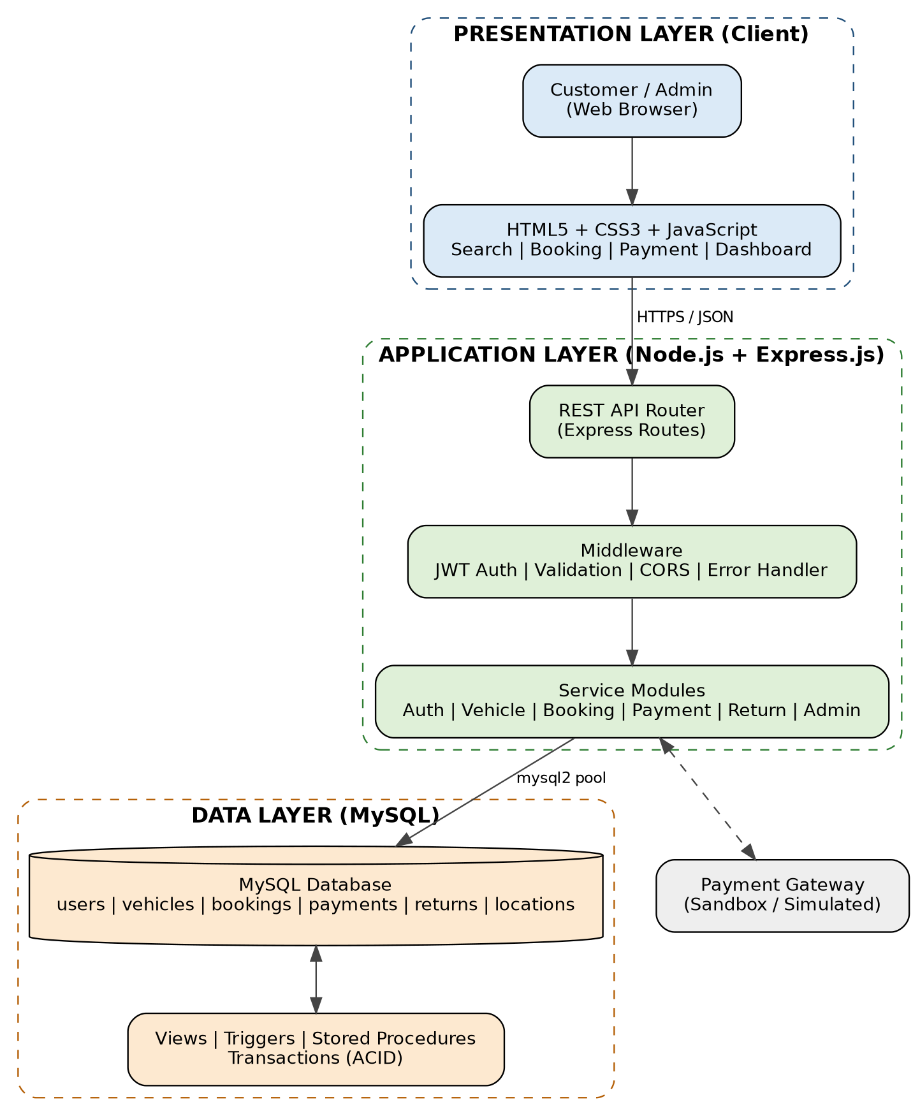
Figure 4.1: High-level architecture of the Car Rentals and Mobility App

4.2 Description of Each Layer

Presentation layer (front end)
The presentation layer runs in the user’s browser. It is responsible for displaying the interface, collecting input and sending requests to the server. It contains no business rules that cannot be re-checked on the server. Basic validation (required fields, valid dates, minimum password length) is performed in the browser for quick feedback, but the server validates everything again.

Application layer (back end)
The application layer is the Node.js and Express server. Incoming requests first pass through middleware (CORS, JSON parsing, JWT verification and role checks) and are then handed to the appropriate route handler. The handlers implement the business logic: checking availability, computing price, creating bookings inside transactions, recording payments, processing returns and generating reports. This layer is the only component that talks to the database, so no credentials are ever exposed to the browser.

Data layer (database)
The data layer is a MySQL database. It stores all persistent information and also enforces the rules that must always hold true, such as unique emails, valid foreign keys, positive rates and end time greater than start time. Views simplify reporting, triggers maintain an audit trail and stored procedures wrap multi-step operations such as cancellation with refund in a single transaction.

Request flow
- The user submits a search or booking form in the browser.
- JavaScript sends an HTTP request with JSON data (and a JWT for protected routes).
- Express middleware validates the token and the input.
- The route handler runs SQL statements through the connection pool, using a transaction where several tables are modified.
- The result is returned to the browser as JSON, and the page is updated.

4.3 Deployment Architecture
For development, all components run on the developer’s machine: the Express server on a local port, MySQL on localhost and the static front end served by Express. For demonstration or production, the same structure can be deployed to the cloud. The Node.js application can be hosted on a platform such as Render or Railway, the MySQL database on a managed MySQL service, and the static front end either from the same Express server or from a static hosting provider. Environment variables hold database credentials, the JWT secret and the allowed origins. Code is pushed to GitHub, and the hosting platform can be configured to rebuild and redeploy automatically on each push to the main branch, giving a simple continuous deployment pipeline.

CHAPTER - 5 DESIGN

5.1 Process Design and Booking Workflow
The central workflow of the application is Search → Select → Book → Pay → Pick Up → Ride → Return. Each step corresponds to one or more database operations, and each booking moves through a set of well-defined states.
Figure 5.1: Main rental workflow
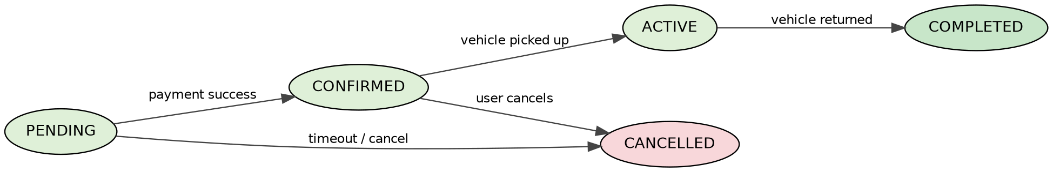
Figure 5.2: Booking status life cycle
Status | Meaning | Triggered by
pending | Booking created, awaiting payment; the vehicle is held for the period. | POST /api/bookings
confirmed | Payment received successfully. | POST /api/payments
active | Customer has picked up the vehicle. | Admin / pickup confirmation
completed | Vehicle returned and charges settled. | POST /api/returns
cancelled | Booking cancelled by the user, admin or by payment timeout. | PUT /api/bookings/:id/cancel
Table 5.1: Booking status definitions

5.2 ER Diagram / Database Schema
The entity-relationship model was prepared by first identifying the entities and their attributes from the problem statement, and then deciding the relationships and their cardinalities. The resulting ER diagram, converted into a relational schema, is shown below.
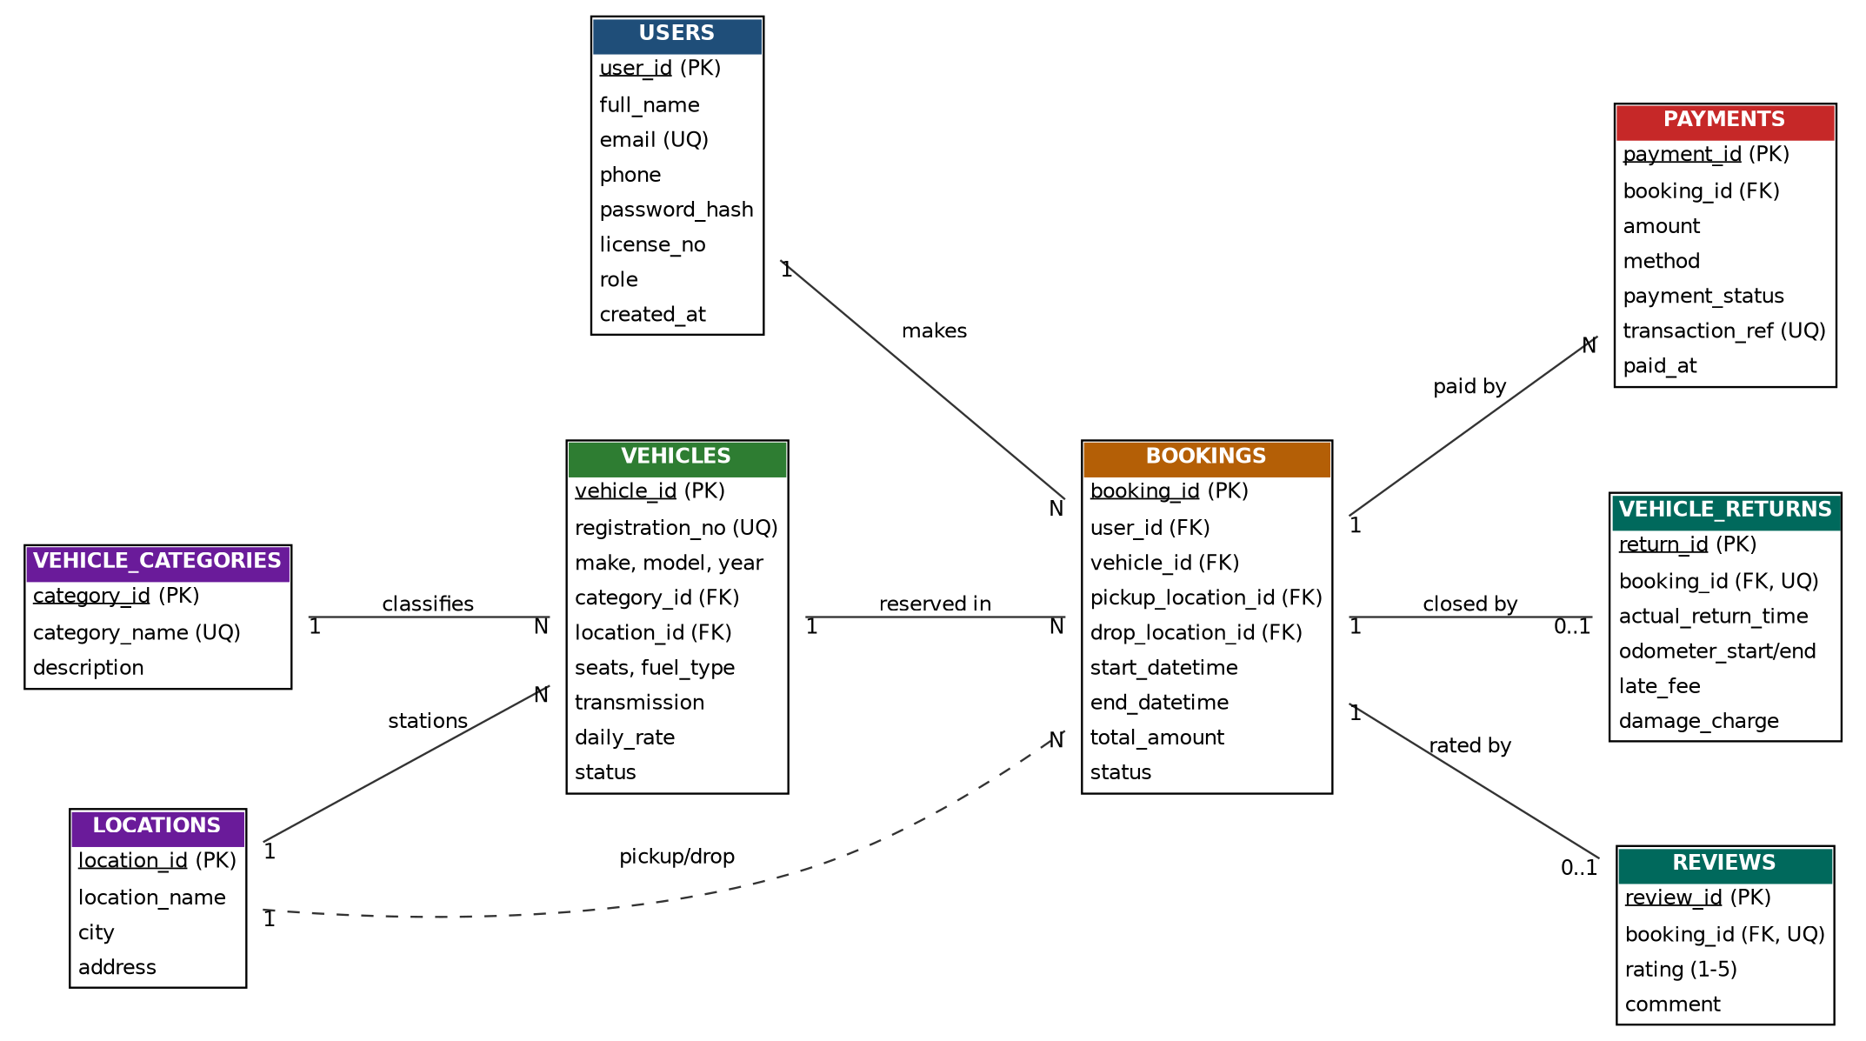
Figure 5.3: Entity-Relationship diagram of the Car Rentals and Mobility App

Entities and relationships
Relationship | Cardinality | Explanation
USERS – BOOKINGS | 1 : N | One user can make many bookings; each booking belongs to exactly one user.
VEHICLES – BOOKINGS | 1 : N | A vehicle can be booked many times (for different periods); each booking is for one vehicle.
VEHICLE_CATEGORIES – VEHICLES | 1 : N | A category (hatchback, sedan, SUV, etc.) groups many vehicles.
LOCATIONS – VEHICLES | 1 : N | A location is the home station of many vehicles.
LOCATIONS – BOOKINGS | 1 : N (twice) | A booking has one pick-up and one drop-off location.
BOOKINGS – PAYMENTS | 1 : N | A booking can have several payment attempts (failed, success, refunded).
BOOKINGS – VEHICLE_RETURNS | 1 : 0..1 | A completed booking has exactly one return record.
BOOKINGS – REVIEWS | 1 : 0..1 | A customer may review a completed booking once.
Table 5.2: Relationships and cardinalities

Relational schema (table structures)
Table | Columns (PK underlined in diagram; FK shown) | Key constraints
users | user_id, full_name, email, phone, password_hash, license_no, role, created_at | PK user_id; UNIQUE email
locations | location_id, location_name, city, address | PK location_id
vehicle_categories | category_id, category_name, description | PK category_id; UNIQUE category_name
vehicles | vehicle_id, registration_no, make, model, model_year, category_id, location_id, seats, fuel_type, transmission, daily_rate, status | PK vehicle_id; UNIQUE registration_no; FK category_id, location_id; CHECK daily_rate > 0
bookings | booking_id, user_id, vehicle_id, pickup_location_id, drop_location_id, start_datetime, end_datetime, total_amount, status, created_at | PK booking_id; FKs to users, vehicles, locations; CHECK end > start
payments | payment_id, booking_id, amount, method, payment_status, transaction_ref, paid_at | PK payment_id; FK booking_id; UNIQUE transaction_ref
vehicle_returns | return_id, booking_id, actual_return_time, odometer_start, odometer_end, late_fee, damage_charge | PK return_id; FK booking_id UNIQUE
reviews | review_id, booking_id, rating, comment | PK review_id; FK booking_id UNIQUE; CHECK rating 1–5
booking_audit | audit_id, booking_id, old_status, new_status, changed_at | PK audit_id (filled by trigger)
Table 5.3: Relational schema

Normalisation
The schema was normalised up to Third Normal Form (3NF) so that redundancy is removed and update anomalies are avoided.
- First Normal Form (1NF): every column holds a single atomic value. A customer’s several phone numbers or a booking’s several payments are not stored in one column; payments, for example, are a separate table.
- Second Normal Form (2NF): every table has a single-column surrogate primary key, so no non-key attribute depends on only part of a composite key.
- Third Normal Form (3NF): there is no transitive dependency. Vehicle category details are not repeated in every vehicle row but are kept in vehicle_categories; location details are kept in locations; customer details are not repeated in bookings.
One deliberate design decision is that total_amount is stored in bookings even though it could be recomputed from the rate and duration. The rate of a vehicle may change in the future, but the price agreed at the time of booking must remain fixed, so storing it is a business requirement and not a normalisation violation.

Indexing and integrity
- A composite index on bookings (vehicle_id, start_datetime, end_datetime) accelerates the availability and overlap checks, which are the most frequent queries.
- An index on bookings (user_id) speeds up the “My Bookings” page.
- Foreign keys use the default RESTRICT behaviour so that a vehicle or user with history cannot be deleted accidentally.
- CHECK constraints guard business rules directly in the database (positive rate, valid time window, rating between 1 and 5).

CHAPTER - 6 IMPLEMENTATION

6.1 Module-wise Implementation
The system is divided into functional modules. Each module has its own routes on the back end and its own screens on the front end, but all modules share the same database and the same authentication mechanism.

Module 1: User Management
This module handles registration, login, profile viewing and profile update. During registration the server validates the input, hashes the password using bcrypt and inserts a row into the users table. The unique constraint on email protects against duplicate accounts. Customers and administrators are distinguished by the role column.

Module 2: Vehicle Management
Administrators use this module to add new vehicles, update rates, change vehicle status and move vehicles between locations. Customers use the read-only side of the module to browse vehicles. Vehicles in maintenance are excluded from all search results.

Module 3: Search and Availability
This module accepts a location and rental period and returns the vehicles that are free. Availability is determined by checking that no booking in the pending, confirmed or active state overlaps the requested period. Two periods overlap when the existing start is earlier than the requested end and the existing end is later than the requested start. Optional filters such as category, fuel type, number of seats and maximum price are applied on top of this basic check.

Module 4: Booking Management
When a user selects a vehicle, this module re-checks availability inside a database transaction, computes the price and inserts the booking. Because the availability check and the insertion occur in the same transaction with the vehicle row locked, two users cannot obtain the same vehicle for overlapping periods. Cancellation is handled by a stored procedure so that the status change and the refund entry succeed or fail together.

Module 5: Payment and Billing
After a booking is created, the user proceeds to payment. The payments route records the amount, method and transaction reference. If the payment is successful the booking status changes to confirmed; if it fails, the booking remains pending and can be retried. Every attempt is stored, which gives a complete audit of money movement.

Module 6: Pick-up and Return
At pick-up the booking becomes active. At return, the administrator enters the actual return time and the odometer reading. The system calculates a late fee when the return time is later than the booked end time, adds any damage charge, stores the data in vehicle_returns, marks the booking completed and makes the vehicle available again.

Module 7: Rental History and Reviews
Users can view all past and current bookings with their payment and return details, and can rate completed trips. Reviews allow operators to understand service quality and give other customers more information.

Module 8: Admin Dashboard and Reports
The dashboard presents counts of vehicles, active rentals and customers, a list of recent bookings and revenue reports produced through aggregate SQL (grouped by month and category) and window functions (ranking vehicles by revenue).

6.2 Front-end Logic
The front end follows a simple pattern: read input, call the API, render the result. When the user submits the search form, a JavaScript function builds a query string from the form values and sends it to the availability endpoint using fetch. The returned JSON array is converted to HTML cards and inserted into the results container. State such as the selected dates, the chosen vehicle and the login token is kept in JavaScript variables and in the browser’s storage so that it survives navigation between pages. Buttons are disabled while a request is in progress to prevent duplicate submissions, and error messages from the server are displayed next to the relevant form.
async function searchVehicles() {
const params = new URLSearchParams({
location: document.getElementById('pickup').value,
start: document.getElementById('start').value,
end: document.getElementById('end').value
});
const res = await fetch('/api/vehicles/available?' + params);
const cars = await res.json();
const list = document.getElementById('results');
list.innerHTML = cars.map(c => `
<div class="car-card">
<h3>${c.make} ${c.model}</h3>
<p>${c.seats} seats | ${c.fuel_type} | ${c.transmission}</p>
<p class="price">Rs. ${c.daily_rate} / day</p>
<button onclick="bookNow(${c.vehicle_id})">Book Now</button>
</div>`).join('');
}
Code Snippet 6.1: Rendering search results in the browser

6.3 API Integration
All communication between the front end and the back end is performed through REST APIs that exchange JSON. The database connection is created once as a pool and shared among requests, which avoids the cost of opening a new connection for each call.
const mysql = require('mysql2/promise');
require('dotenv').config();

const pool = mysql.createPool({
host: process.env.DB_HOST,
user: process.env.DB_USER,
password: process.env.DB_PASSWORD,
database: process.env.DB_NAME,
waitForConnections: true,
connectionLimit: 10,
dateStrings: true
});

module.exports = pool;
Code Snippet 6.2: MySQL connection pool (db.js)
The booking route is the most important piece of back-end logic, because it combines locking, validation, price calculation and insertion in one transaction.
const express = require('express');
const pool = require('../db');
const { verifyToken } = require('../middleware/auth');
const router = express.Router();

// POST /api/bookings : create a booking without double-booking
router.post('/', verifyToken, async (req, res) => {
const { vehicle_id, pickup_location_id, drop_location_id, start, end } = req.body;
if (!vehicle_id || !start || !end || new Date(end) <= new Date(start))
return res.status(400).json({ message: 'Invalid booking details' });

const conn = await pool.getConnection();
try {
await conn.beginTransaction();

// 1. Lock the vehicle row so concurrent requests are serialised
const [veh] = await conn.query(
'SELECT daily_rate, status FROM vehicles WHERE vehicle_id = ? FOR UPDATE',
[vehicle_id]);
if (!veh.length || veh[0].status === 'maintenance') {
await conn.rollback();
return res.status(404).json({ message: 'Vehicle not available' });
}

// 2. Overlap check: existing.start < new.end AND existing.end > new.start
const [clash] = await conn.query(
`SELECT booking_id FROM bookings
WHERE vehicle_id = ? AND status IN ('pending','confirmed','active')
AND start_datetime < ? AND end_datetime > ?`,
[vehicle_id, end, start]);
if (clash.length) {
await conn.rollback();
return res.status(409).json({ message: 'Vehicle already booked for this period' });
}

// 3. Price = number of 24-hour blocks (rounded up) x daily rate
const hours = (new Date(end) - new Date(start)) / 3600000;
const total = Math.ceil(hours / 24) * veh[0].daily_rate;

// 4. Insert the booking
const [result] = await conn.query(
`INSERT INTO bookings (user_id, vehicle_id, pickup_location_id, drop_location_id,
start_datetime, end_datetime, total_amount)
VALUES (?, ?, ?, ?, ?, ?, ?)`,
[req.user.id, vehicle_id, pickup_location_id, drop_location_id, start, end, total]);

await conn.commit();
res.status(201).json({ booking_id: result.insertId, total_amount: total, status: 'pending' });
} catch (err) {
await conn.rollback();
res.status(500).json({ message: 'Booking failed', error: err.message });
} finally {
conn.release();
}
});

module.exports = router;
Code Snippet 6.3: Transaction-safe booking creation (routes/booking.js)
The vehicle row is locked with SELECT ... FOR UPDATE at the start of the transaction. Any other request for the same vehicle must wait until the first transaction commits or rolls back. When it proceeds, its overlap check will see the newly inserted booking and will be rejected with HTTP 409. This is the practical application of ACID properties and isolation covered in the course.

6.4 Authentication and Authorization
Authentication verifies who the user is; authorization decides what the user may do. Registration hashes the password with bcrypt, and login compares the entered password with the stored hash. On success, the server signs a JWT that contains the user id and role and expires after two hours.
const bcrypt = require('bcrypt');
const jwt = require('jsonwebtoken');

router.post('/register', async (req, res) => {
const { full_name, email, phone, password, license_no } = req.body;
const hash = await bcrypt.hash(password, 10);
try {
const [r] = await pool.query(
'INSERT INTO users (full_name,email,phone,password_hash,license_no) VALUES (?,?,?,?,?)',
[full_name, email, phone, hash, license_no]);
res.status(201).json({ user_id: r.insertId });
} catch (e) {
if (e.code === 'ER_DUP_ENTRY') return res.status(409).json({ message: 'Email already registered' });
res.status(500).json({ message: 'Registration failed' });
}
});

router.post('/login', async (req, res) => {
const { email, password } = req.body;
const [rows] = await pool.query('SELECT * FROM users WHERE email = ?', [email]);
if (!rows.length || !(await bcrypt.compare(password, rows[0].password_hash)))
return res.status(401).json({ message: 'Invalid credentials' });
const token = jwt.sign({ id: rows[0].user_id, role: rows[0].role },
process.env.JWT_SECRET, { expiresIn: '2h' });
res.json({ token, role: rows[0].role });
});
Code Snippet 6.4: Registration and login with bcrypt and JWT
Two middleware functions protect the routes. verifyToken checks the Authorization header and rejects missing or invalid tokens with 401. requireAdmin allows access only when the token’s role is admin and otherwise returns 403.
const jwt = require('jsonwebtoken');

function verifyToken(req, res, next) {
const header = req.headers['authorization'] || '';
const token = header.startsWith('Bearer ') ? header.slice(7) : null;
if (!token) return res.status(401).json({ message: 'Token missing' });
try {
req.user = jwt.verify(token, process.env.JWT_SECRET);
next();
} catch (err) {
return res.status(401).json({ message: 'Invalid or expired token' });
}
}

function requireAdmin(req, res, next) {
if (req.user.role !== 'admin')
return res.status(403).json({ message: 'Admin access required' });
next();
}

module.exports = { verifyToken, requireAdmin };
Code Snippet 6.5: Authentication and role middleware (middleware/auth.js)

6.5 Database Implementation (DDL, DML, Views, Triggers, Transactions)
The complete schema is created with DDL statements that include primary keys, foreign keys, unique constraints, CHECK constraints and indexes.
CREATE DATABASE IF NOT EXISTS car_rental_db;
USE car_rental_db;

CREATE TABLE users (
user_id INT AUTO_INCREMENT PRIMARY KEY,
full_name VARCHAR(100) NOT NULL,
email VARCHAR(120) NOT NULL UNIQUE,
phone VARCHAR(15) NOT NULL,
password_hash VARCHAR(255) NOT NULL,
license_no VARCHAR(30),
role ENUM('customer','admin') NOT NULL DEFAULT 'customer',
created_at TIMESTAMP DEFAULT CURRENT_TIMESTAMP
);

CREATE TABLE locations (
location_id INT AUTO_INCREMENT PRIMARY KEY,
location_name VARCHAR(80) NOT NULL,
city VARCHAR(60) NOT NULL,
address VARCHAR(200) NOT NULL
);

CREATE TABLE vehicle_categories (
category_id INT AUTO_INCREMENT PRIMARY KEY,
category_name VARCHAR(40) NOT NULL UNIQUE,
description VARCHAR(200)
);

CREATE TABLE vehicles (
vehicle_id INT AUTO_INCREMENT PRIMARY KEY,
registration_no VARCHAR(20) NOT NULL UNIQUE,
make VARCHAR(40) NOT NULL,
model VARCHAR(40) NOT NULL,
model_year YEAR NOT NULL,
category_id INT NOT NULL,
location_id INT NOT NULL,
seats TINYINT NOT NULL,
fuel_type ENUM('Petrol','Diesel','CNG','Electric','Hybrid') NOT NULL,
transmission ENUM('Manual','Automatic') NOT NULL,
daily_rate DECIMAL(10,2) NOT NULL CHECK (daily_rate > 0),
status ENUM('available','booked','maintenance') NOT NULL DEFAULT 'available',
FOREIGN KEY (category_id) REFERENCES vehicle_categories(category_id),
FOREIGN KEY (location_id) REFERENCES locations(location_id)
);

CREATE TABLE bookings (
booking_id INT AUTO_INCREMENT PRIMARY KEY,
user_id INT NOT NULL,
vehicle_id INT NOT NULL,
pickup_location_id INT NOT NULL,
drop_location_id INT NOT NULL,
start_datetime DATETIME NOT NULL,
end_datetime DATETIME NOT NULL,
total_amount DECIMAL(10,2) NOT NULL,
status ENUM('pending','confirmed','active','completed','cancelled')
NOT NULL DEFAULT 'pending',
created_at TIMESTAMP DEFAULT CURRENT_TIMESTAMP,
CHECK (end_datetime > start_datetime),
FOREIGN KEY (user_id) REFERENCES users(user_id),
FOREIGN KEY (vehicle_id) REFERENCES vehicles(vehicle_id),
FOREIGN KEY (pickup_location_id) REFERENCES locations(location_id),
FOREIGN KEY (drop_location_id) REFERENCES locations(location_id),
INDEX idx_vehicle_period (vehicle_id, start_datetime, end_datetime),
INDEX idx_user (user_id)
);

CREATE TABLE payments (
payment_id INT AUTO_INCREMENT PRIMARY KEY,
booking_id INT NOT NULL,
amount DECIMAL(10,2) NOT NULL,
method ENUM('UPI','Card','NetBanking','Wallet') NOT NULL,
payment_status ENUM('success','failed','refunded') NOT NULL,
transaction_ref VARCHAR(50) NOT NULL UNIQUE,
paid_at TIMESTAMP DEFAULT CURRENT_TIMESTAMP,
FOREIGN KEY (booking_id) REFERENCES bookings(booking_id)
);

CREATE TABLE vehicle_returns (
return_id INT AUTO_INCREMENT PRIMARY KEY,
booking_id INT NOT NULL UNIQUE,
actual_return_time DATETIME NOT NULL,
odometer_start INT NOT NULL,
odometer_end INT NOT NULL,
late_fee DECIMAL(10,2) NOT NULL DEFAULT 0,
damage_charge DECIMAL(10,2) NOT NULL DEFAULT 0,
FOREIGN KEY (booking_id) REFERENCES bookings(booking_id)
);

CREATE TABLE reviews (
review_id INT AUTO_INCREMENT PRIMARY KEY,
booking_id INT NOT NULL UNIQUE,
rating TINYINT NOT NULL CHECK (rating BETWEEN 1 AND 5),
comment VARCHAR(300),
FOREIGN KEY (booking_id) REFERENCES bookings(booking_id)
);

CREATE TABLE booking_audit (
audit_id INT AUTO_INCREMENT PRIMARY KEY,
booking_id INT NOT NULL,
old_status VARCHAR(20),
new_status VARCHAR(20),
changed_at TIMESTAMP DEFAULT CURRENT_TIMESTAMP
);
Code Snippet 6.6: DDL script for the database (schema.sql)
The advanced SQL queries that support search and reporting are shown below. They demonstrate anti-join with NOT EXISTS, multi-table joins, subqueries with aggregate comparison, common table expressions and window functions.
-- Q1: Vehicles available at a location for a requested period (anti-join)
SELECT v.vehicle_id, v.make, v.model, v.daily_rate
FROM vehicles v
WHERE v.location_id = 1
AND v.status <> 'maintenance'
AND NOT EXISTS (
SELECT 1 FROM bookings b
WHERE b.vehicle_id = v.vehicle_id
AND b.status IN ('pending','confirmed','active')
AND b.start_datetime < '2026-11-05 18:00:00'
AND b.end_datetime > '2026-11-03 09:00:00');

-- Q2: Booking details using multi-table JOIN
SELECT b.booking_id, u.full_name, v.make, v.model,
b.start_datetime, b.end_datetime, b.total_amount, b.status
FROM bookings b
JOIN users u ON u.user_id = b.user_id
JOIN vehicles v ON v.vehicle_id = b.vehicle_id
ORDER BY b.created_at DESC;

-- Q3: Customers who spent more than the average (subquery)
SELECT u.full_name, SUM(p.amount) AS total_spent
FROM users u
JOIN bookings b ON b.user_id = u.user_id
JOIN payments p ON p.booking_id = b.booking_id AND p.payment_status = 'success'
GROUP BY u.user_id, u.full_name
HAVING SUM(p.amount) > (SELECT AVG(amount) FROM payments WHERE payment_status = 'success');

-- Q4: Monthly revenue per category (CTE + aggregate)
WITH paid AS (
SELECT b.vehicle_id, p.amount, DATE_FORMAT(p.paid_at, '%Y-%m') AS ym
FROM payments p JOIN bookings b ON b.booking_id = p.booking_id
WHERE p.payment_status = 'success'
)
SELECT c.category_name, paid.ym, SUM(paid.amount) AS revenue
FROM paid
JOIN vehicles v ON v.vehicle_id = paid.vehicle_id
JOIN vehicle_categories c ON c.category_id = v.category_id
GROUP BY c.category_name, paid.ym;

-- Q5: Rank vehicles by revenue inside each category (window function)
SELECT category_name, vehicle_id, revenue,
RANK() OVER (PARTITION BY category_name ORDER BY revenue DESC) AS rank_in_category
FROM (
SELECT c.category_name, v.vehicle_id, SUM(p.amount) AS revenue
FROM payments p
JOIN bookings b ON b.booking_id = p.booking_id
JOIN vehicles v ON v.vehicle_id = b.vehicle_id
JOIN vehicle_categories c ON c.category_id = v.category_id
WHERE p.payment_status = 'success'
GROUP BY c.category_name, v.vehicle_id
) t;
Code Snippet 6.7: Advanced SQL queries (queries.sql)
A view simplifies the most common reporting join. A trigger records every change in booking status in an audit table, and a stored procedure cancels a booking and refunds its payment inside one transaction.
CREATE VIEW v_booking_details AS
SELECT b.booking_id, u.full_name AS customer, v.registration_no,
CONCAT(v.make,' ',v.model) AS vehicle,
b.start_datetime, b.end_datetime, b.total_amount, b.status
FROM bookings b
JOIN users u ON u.user_id = b.user_id
JOIN vehicles v ON v.vehicle_id = b.vehicle_id;

DELIMITER //
CREATE TRIGGER trg_booking_status_audit
AFTER UPDATE ON bookings
FOR EACH ROW
BEGIN
IF OLD.status <> NEW.status THEN
INSERT INTO booking_audit (booking_id, old_status, new_status)
VALUES (OLD.booking_id, OLD.status, NEW.status);
END IF;
END//

CREATE PROCEDURE sp_cancel_booking(IN p_booking_id INT)
BEGIN
DECLARE EXIT HANDLER FOR SQLEXCEPTION
BEGIN ROLLBACK; RESIGNAL; END;
START TRANSACTION;
UPDATE bookings SET status = 'cancelled'
WHERE booking_id = p_booking_id AND status IN ('pending','confirmed');
UPDATE payments SET payment_status = 'refunded'
WHERE booking_id = p_booking_id AND payment_status = 'success';
COMMIT;
END//
DELIMITER ;
Code Snippet 6.8: View, trigger and stored procedure

CHAPTER - 7 FEATURES

7.1 List of Main Features
- Secure registration and login with role-based access.
- Vehicle catalogue with images, specifications and daily rate.
- Search by location and rental period with real-time availability.
- Filters by category, fuel type, transmission, seats and price.
- Self-service booking with automatic price calculation.
- Double-booking prevention using transactions and row locking.
- Online payment recording with unique transaction reference.
- Booking confirmation, cancellation and refund tracking.
- Pick-up and drop-off location selection.
- Vehicle return processing with late fee and damage charges.
- Complete rental history for every user.
- Ratings and reviews for completed trips.
- Admin dashboard for vehicles, bookings, customers and revenue.
- Automatic audit trail of booking status changes.

7.2 How Each Feature Works
Feature | User perspective | Technical description
Registration and login | User fills a short form and receives access to personal pages. | Password hashed with bcrypt; JWT issued and sent in the Authorization header for protected routes.
Search and filter | User enters location and dates and sees only the cars that are free. | NOT EXISTS anti-join on bookings using the overlap condition; parameters bound to prevent SQL injection.
Booking | User clicks Book Now, reviews the total and confirms. | Transaction locks the vehicle row, re-checks overlap, computes price (24-hour blocks x daily rate) and inserts the booking.
Payment | User chooses UPI, card, net banking or wallet and pays. | Payment row inserted with unique transaction_ref; booking status updated to confirmed in the same transaction.
Cancellation | User cancels from My Bookings and sees refund status. | Stored procedure sp_cancel_booking updates booking and payment atomically; trigger writes an audit row.
Return and billing | Customer returns the car; final bill is generated. | Admin enters return time and odometer; late fee = hours late x hourly rate x surcharge; booking set to completed.
Rental history | User sees all trips with amounts and statuses. | JOIN of bookings, vehicles, payments and returns filtered by user_id and sorted by date.
Reviews | User rates a completed trip from 1 to 5. | Reviews table with UNIQUE booking_id and CHECK on rating.
Admin dashboard | Admin views fleet, active rentals and revenue. | Aggregates, CTEs and window functions over bookings and payments; routes protected by requireAdmin.
Table 7.1: Working of main features
Price calculation: the rental duration is converted to hours and rounded up to the next full 24-hour block. For example, a booking from 3 November 09:00 to 5 November 18:00 lasts 57 hours, which is three 24-hour blocks, and is therefore charged as three days. Late fees on return are charged per hour of delay at a rate derived from the daily rate; the exact late-fee policy is a configurable business rule.

CHAPTER - 8 TESTING

8.1 Postman Testing (Frontend/Backend)
Postman was used to test the REST API independently of the user interface. A collection was created with folders for Auth, Vehicles, Bookings, Payments, Returns and Admin. Environment variables store the base URL and the JWT, which is captured automatically from the login response by a small script in the Tests tab and reused in the Authorization header of later requests.
For every endpoint, both valid and invalid requests were prepared. Positive tests confirm the expected status code and response structure; negative tests confirm that errors are handled properly. The main checks were:
- Registration with a duplicate email returns 409.
- Login with a wrong password returns 401.
- Accessing a protected route without a token returns 401, and with an expired token returns 401.
- A customer calling an admin route returns 403.
- Booking with an end time earlier than the start time returns 400.
- Booking a vehicle that already has an overlapping booking returns 409.
- Booking a vehicle under maintenance returns 404.
- SQL-injection style strings in search parameters do not alter the query because parameters are bound.
Assertions written in the Tests tab verify status codes, response time and the presence of fields such as booking_id and total_amount. The collection can be run in sequence using the Collection Runner to check the full workflow from registration to booking and payment, and it is stored in the GitHub repository so that all team members use the same tests.

8.2 Integration Testing
Integration testing verifies that the front end, back end and database work correctly together. The important scenarios were the complete customer journey (register, log in, search, book, pay, view history), the administrator journey (add vehicle, view bookings, process return), and the concurrency scenario. In the concurrency test, two booking requests for the same vehicle and overlapping dates were sent almost simultaneously from two Postman runners. The expected and observed behaviour of a correct implementation is that one request succeeds with 201 and the other fails with 409, and the database contains exactly one booking for that period.
Database-level integration checks included verifying that the trigger writes an audit row on every status change, that the cancellation procedure rolls back completely if any statement fails, and that foreign key constraints prevent orphan rows.

8.3 Tools Used for Testing
Tool | Use
Postman | API functional testing, automated assertions and Collection Runner.
MySQL Workbench | Verifying table contents, constraints, triggers and execution plans (EXPLAIN).
Browser developer tools | Inspecting network calls, console errors and responsive layouts.
Multiple browsers | Cross-browser checks on Chrome, Edge and Firefox.
Git and GitHub | Tracking fixes and re-testing after each change.
Table 8.1: Testing tools

8.4 Test Cases and Results
The table below lists the principal test cases. The “Actual result / Status” column is to be completed by the team after executing each case on the final build and attaching Postman or screenshot evidence in the appendix.
ID | Module | Test scenario | Expected result | Actual result / Status
TC01 | Auth | Register with valid details | 201 Created; user row inserted
TC02 | Auth | Register with existing email | 409 Conflict
TC03 | Auth | Login with valid credentials | 200 OK; JWT returned
TC04 | Auth | Login with wrong password | 401 Unauthorized
TC05 | Vehicles | List vehicles with category filter | Only vehicles of that category returned
TC06 | Availability | Search for dates with an existing overlapping booking | Booked vehicle not shown
TC07 | Availability | Search for dates adjacent to an existing booking (end = new start) | Vehicle is shown (no overlap)
TC08 | Booking | Create booking for a free vehicle | 201; total = blocks x daily_rate
TC09 | Booking | Create overlapping booking | 409 Conflict
TC10 | Booking | End time before start time | 400 Bad Request
TC11 | Booking | Two simultaneous requests for same vehicle | Exactly one succeeds
TC12 | Payment | Successful payment | Payment saved; booking confirmed
TC13 | Payment | Failed payment | Booking stays pending; failed row stored
TC14 | Cancellation | Cancel confirmed booking | Booking cancelled; payment refunded; audit row added
TC15 | Return | Return after end time | Late fee calculated; booking completed
TC16 | Security | Customer calls admin endpoint | 403 Forbidden
TC17 | Security | Request with no token | 401 Unauthorized
TC18 | Security | SQL injection string in search | No error; no data leakage
TC19 | UI | Open site on mobile screen width | Layout adapts; no horizontal scroll
TC20 | Admin | Add a new vehicle | Vehicle appears in catalogue
Table 8.2: Test cases

CHAPTER - 9 DEPLOYMENT

9.1 Steps to Deploy

Local deployment
- Install Node.js (LTS) and MySQL 8 on the machine.
- Clone the project from GitHub: git clone <repository-url> and open the folder in VS Code.
- Run npm install in the project folder to download the dependencies.
- Open MySQL Workbench and execute schema.sql to create the database and tables, followed by txn.sql for the view, trigger and procedure, and a seed script for sample locations, categories and vehicles.
- Create a .env file with the database and JWT settings (see Section 9.2).
- Start the server with npm start (or node server.js).
- Open http://localhost:5000 in a browser to use the application.

Cloud deployment
- Push the final code to the main branch of the GitHub repository.
- Create a managed MySQL instance with a cloud provider and import schema.sql and txn.sql.
- Create a web service on a Node hosting platform (for example Render or Railway) and connect it to the GitHub repository.
- Set the build command (npm install) and start command (npm start).
- Enter the environment variables in the platform’s dashboard.
- Deploy, open the generated public URL and run the smoke tests listed in Section 9.3.

9.2 Environment Configuration
All configuration that differs between environments is kept in environment variables rather than in source code. A .env file is used locally and is excluded from Git through .gitignore; on the hosting platform the same names are entered in the dashboard.
PORT=5000
DB_HOST=localhost
DB_USER=root
DB_PASSWORD=your_mysql_password
DB_NAME=car_rental_db
JWT_SECRET=change_this_to_a_long_random_string
Code Snippet 9.1: Sample .env file
Variable | Purpose
PORT | Port on which the Express server listens.
DB_HOST, DB_USER, DB_PASSWORD, DB_NAME | MySQL connection details.
JWT_SECRET | Secret used to sign and verify tokens; must be long and random.
Table 9.1: Environment variables

9.3 Hosting of Frontend and Backend
Two hosting arrangements are supported. In the simple arrangement the Express server serves the static HTML, CSS and JavaScript files and the API from the same origin, so a single deployment is enough and no CORS configuration is required. In the split arrangement the front end is placed on a static hosting provider and the API on a separate Node service; in this case the allowed origin is configured in the CORS middleware and the front end uses the API base URL of the deployed service. The database is hosted separately on a managed MySQL service and is accessed only by the back end.
After each deployment a short smoke test is performed: open the home page, search for vehicles, log in, create a test booking and confirm that the booking appears in the admin dashboard. Backups of the database should be taken regularly using mysqldump or the provider’s snapshot feature.

CHAPTER - 10 CHALLENGES & LIMITATIONS

10.1 Issues Faced During Development
- Preventing double booking. Checking availability and then inserting a booking in two separate steps allowed two concurrent users to obtain the same vehicle.
- Defining overlap correctly. Early versions of the date comparison wrongly blocked back-to-back bookings, where one rental ends exactly when the next begins.
- Slow search queries. Availability queries became slower as the number of bookings grew.
- Asynchronous code. Callbacks and promises in Node.js produced errors when database calls were not awaited correctly.
- Connection handling. Connections were not released after errors, which exhausted the pool.
- Cross-origin errors. The browser blocked API calls when the front end and back end ran on different ports.
- Date and time zones. Differences between browser local time and database time caused wrong rental durations.
- Team coordination. Three members working on the same files created merge conflicts.

10.2 Solutions Applied
Issue | Solution
Double booking | Wrapped availability check and insert in one transaction and locked the vehicle row with SELECT ... FOR UPDATE.
Overlap logic | Used the strict comparison existing.start < new.end AND existing.end > new.start, which allows adjacent bookings.
Slow queries | Added a composite index on (vehicle_id, start_datetime, end_datetime) and verified with EXPLAIN.
Async errors | Used async/await with try/catch in every route and a central error handler.
Connection leaks | Used a connection pool and released connections in a finally block.
CORS | Enabled the cors middleware with a configured allowed origin, or served the front end from Express.
Time zones | Stored and compared times in a single consistent format and returned dates as strings.
Merge conflicts | Adopted feature branches, small commits and pull-request reviews.
Table 10.1: Problems and solutions

10.3 Current Limitations or Known Bugs
- Payments are simulated; a real payment gateway with webhooks is not yet integrated.
- Driving licence and identity documents are stored as text and not verified automatically.
- There is no live GPS tracking, and vehicle handover relies on an administrator action instead of keyless entry.
- Pricing is a fixed daily rate; there is no weekend, seasonal or demand-based pricing.
- Notifications by email, SMS or push are not implemented.
- The application is a web app only; there is no native mobile application.
- Unpaid pending bookings need a scheduled job to expire them automatically.
- The system has been tested with sample data and a small number of concurrent users, not with production-scale traffic.

CHAPTER - 11 FUTURE ENHANCEMENTS

11.1 Planned Features
- GPS-based vehicle tracking: show live location, trip distance and geofence alerts.
- EV charging station integration: support electric vehicles with charger locations and battery-aware trip planning.
- Smart-lock / keyless access: unlock the vehicle through the app after booking verification.
- AI-based vehicle recommendations: suggest vehicles using past trips and preferences.
- Demand-based dynamic pricing: adjust rates according to demand, season and utilisation.
- Digital document verification: verify licence and ID using OCR and government APIs.
- Push notifications: booking reminders, return alerts and offers.
- Loyalty and subscription programmes: reward frequent users and offer monthly plans.
- Multi-city and multi-country expansion: support more regions, currencies and languages.

11.2 Possible Integrations or Optimisations
- Integrate Razorpay or Stripe for live payments, refunds and invoices.
- Use Redis caching for frequently requested vehicle lists.
- Add read replicas and partitioning of the bookings table for very large datasets, bringing the distributed-database aspects of the course into practice.
- Containerise the back end with Docker and automate tests and deployment through a CI/CD pipeline.
- Introduce a message queue for notifications and for expiring unpaid bookings.
- Add monitoring, logging and alerts for production use.
- Provide Android and iOS applications using the same REST API.

CHAPTER – 12 CONCLUSION

12.1 Summary of the Project
The Car Rentals and Mobility App for Rental Self Service is a database-driven web application that replaces the manual car rental process with a simple online workflow. A user can search for available cars, compare prices, make a booking, pay, pick up the vehicle and return it, while the administrator manages the fleet and monitors operations from one dashboard. The solution is built using HTML, CSS and JavaScript on the front end, Node.js and Express.js on the back end and a normalised MySQL database at the core.

12.2 What Was Achieved
- Analysed the rental domain and prepared an ER model with entities, relationships and cardinalities.
- Designed a schema normalised to 3NF with primary keys, foreign keys, CHECK constraints and indexes.
- Implemented advanced SQL queries using joins, subqueries, CTEs, aggregates and window functions.
- Implemented a transaction-safe booking process that prevents double booking.
- Added views, a trigger-based audit trail and a stored procedure for cancellation with refund.
- Developed a REST API with JWT authentication and role-based authorisation.
- Built a responsive interface for customers and administrators.
- Prepared Postman test collections and a test plan for functional, integration and security testing.
The project meets its objectives of reducing manual work, providing real-time availability and offering a convenient self-service experience, while demonstrating the use of database systems and backend technologies for a reliable and scalable mobility application.

12.3 Skills Learned During Development
Area | Skills gained
Database design | ER modelling, schema design, normalisation, constraints and indexing.
SQL | DDL, DML, joins, subqueries, CTEs, window functions, views, triggers and stored procedures.
Transactions | ACID properties, isolation, row-level locking and handling concurrent bookings.
Back-end development | Node.js, Express routing, middleware, connection pooling and error handling.
Security | Password hashing, JWT authentication, role-based access and SQL injection prevention.
Front-end development | HTML, CSS, responsive layout, Fetch API and dynamic rendering.
Tools and teamwork | Git/GitHub workflow, Postman testing, VS Code, task division and documentation.
Table 12.1: Skills learned

CHAPTER - 13 REFERENCES

Books
- Elmasri, R., & Navathe, S. B. (2016). Fundamentals of Database Systems (7th ed.). Pearson.
- Silberschatz, A., Korth, H. F., & Sudarshan, S. (2019). Database System Concepts (7th ed.). McGraw-Hill Education.
- Ramakrishnan, R., & Gehrke, J. (2003). Database Management Systems (3rd ed.). McGraw-Hill.
- Pressman, R. S., & Maxim, B. R. (2019). Software Engineering: A Practitioner’s Approach (9th ed.). McGraw-Hill Education.
- Sommerville, I. (2016). Software Engineering (10th ed.). Pearson Education.
- Haverbeke, M. (2018). Eloquent JavaScript (3rd ed.). No Starch Press.

Documentation and Tutorials
- MySQL 8.0 Reference Manual. Oracle Corporation. https://dev.mysql.com/doc/
- Node.js Documentation. OpenJS Foundation. https://nodejs.org/docs/
- Express.js Guide. https://expressjs.com/
- MDN Web Docs: HTML, CSS and JavaScript. Mozilla. https://developer.mozilla.org/
- Postman Learning Center. https://learning.postman.com/
- Pro Git Book. https://git-scm.com/book
- W3Schools. HTML, CSS, JavaScript and SQL Tutorials. https://www.w3schools.com/
- GeeksforGeeks. DBMS and Web Development Tutorials. https://www.geeksforgeeks.org/

Standards and Security References
- Jones, M., Bradley, J., & Sakimura, N. (2015). JSON Web Token (JWT), RFC 7519. IETF.
- OWASP Foundation. OWASP Top Ten Web Application Security Risks. https://owasp.org/www-project-top-ten/
- npm packages: express, mysql2, bcrypt, jsonwebtoken, dotenv, cors. https://www.npmjs.com/

CHAPTER - 14 APPENDICES

A. Screenshots of the App
Insert the final screenshots in the boxes below (one per screen).

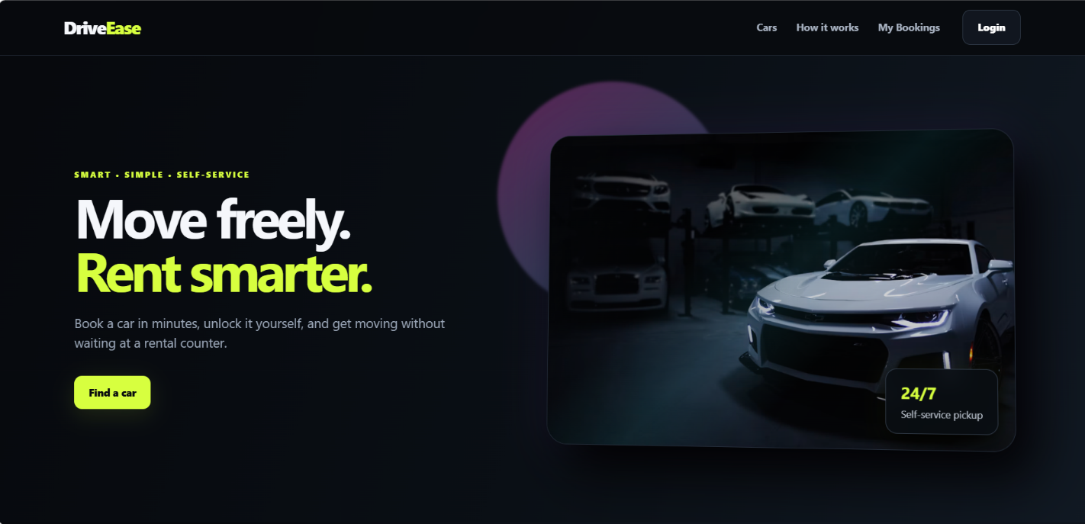
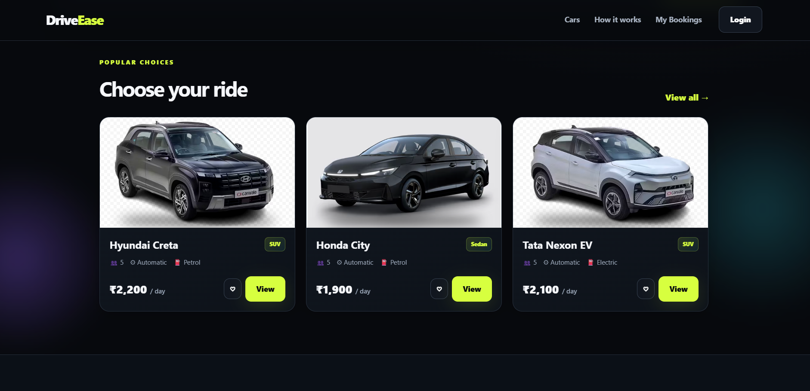
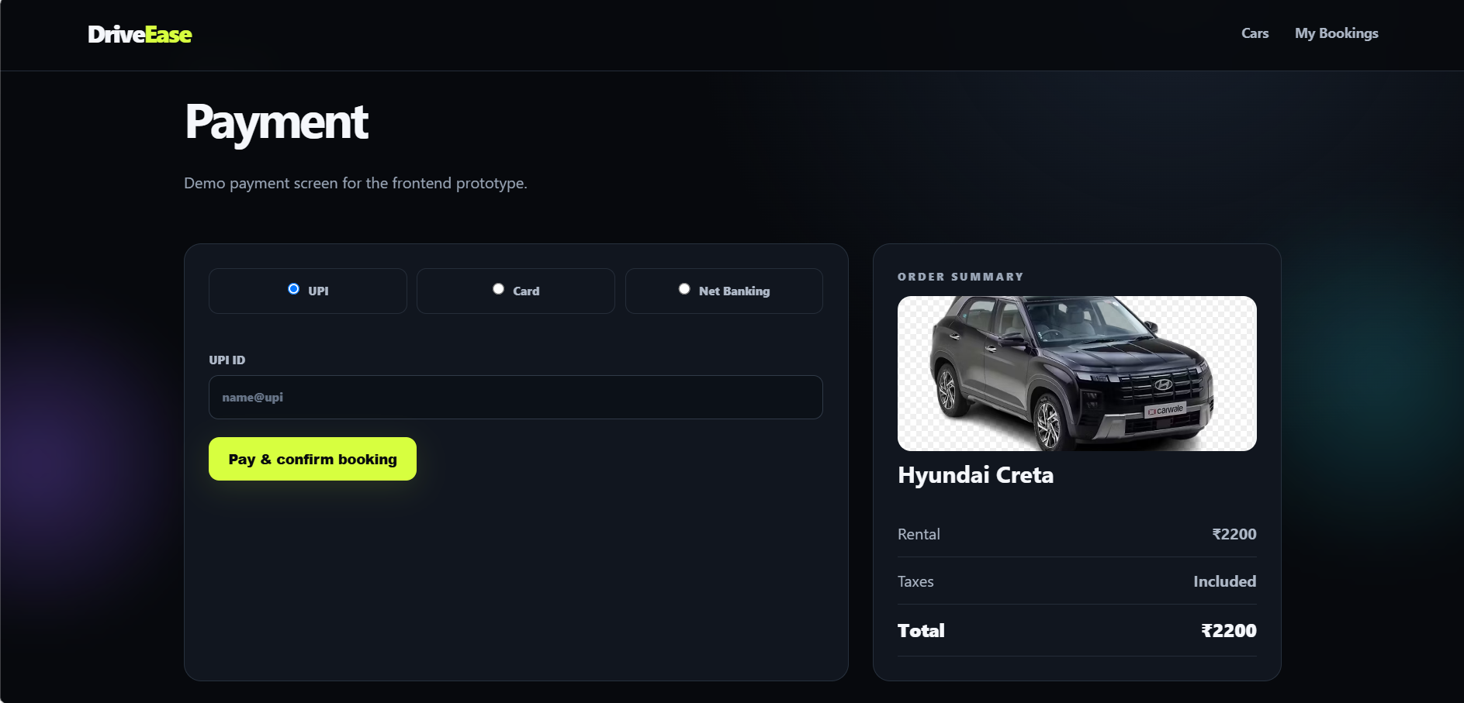
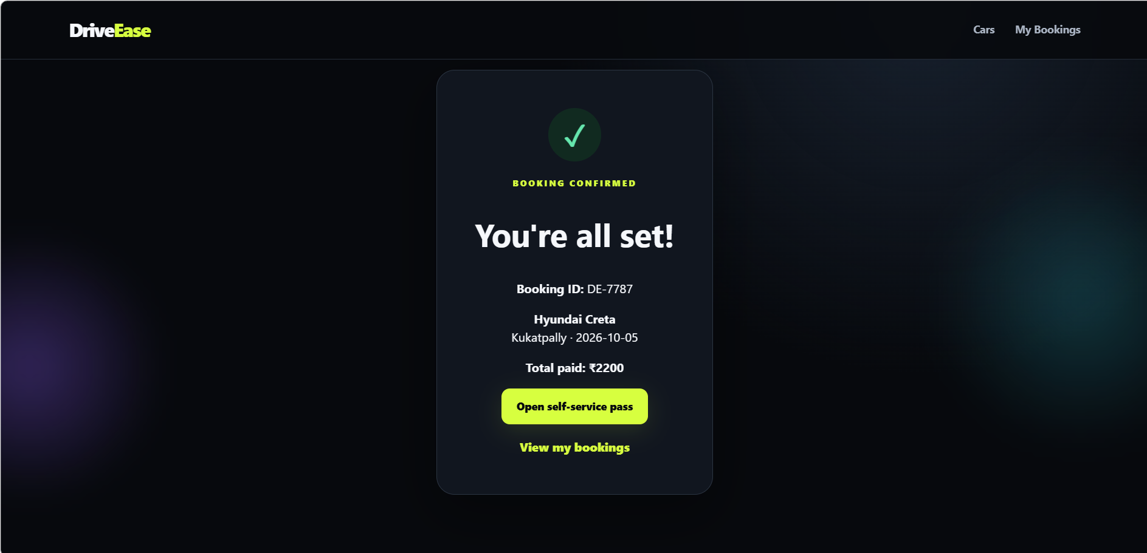
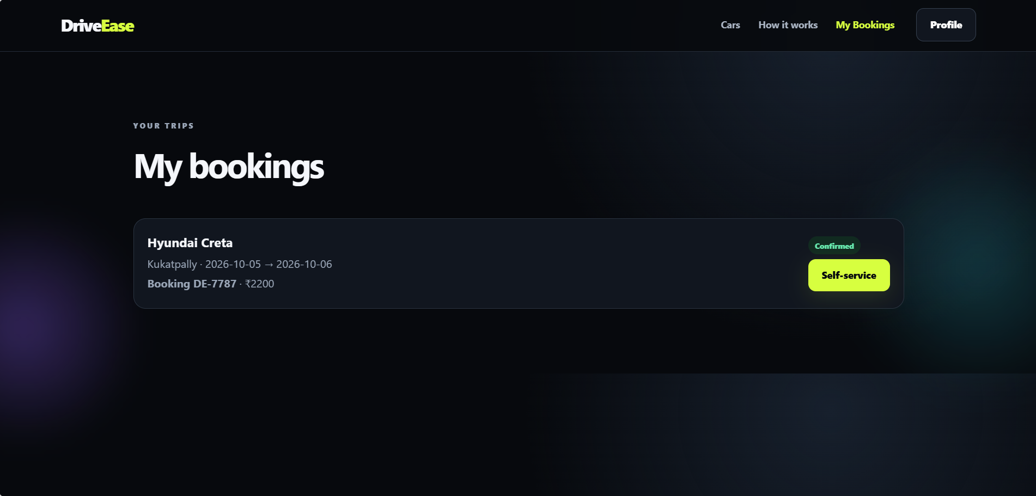

B. Sample Code Snippets
The main code listings are given in Chapter 6 (Code Snippets 6.1 to 6.8). Additional code such as the seed data script and the full route files is available in the GitHub repository of the project.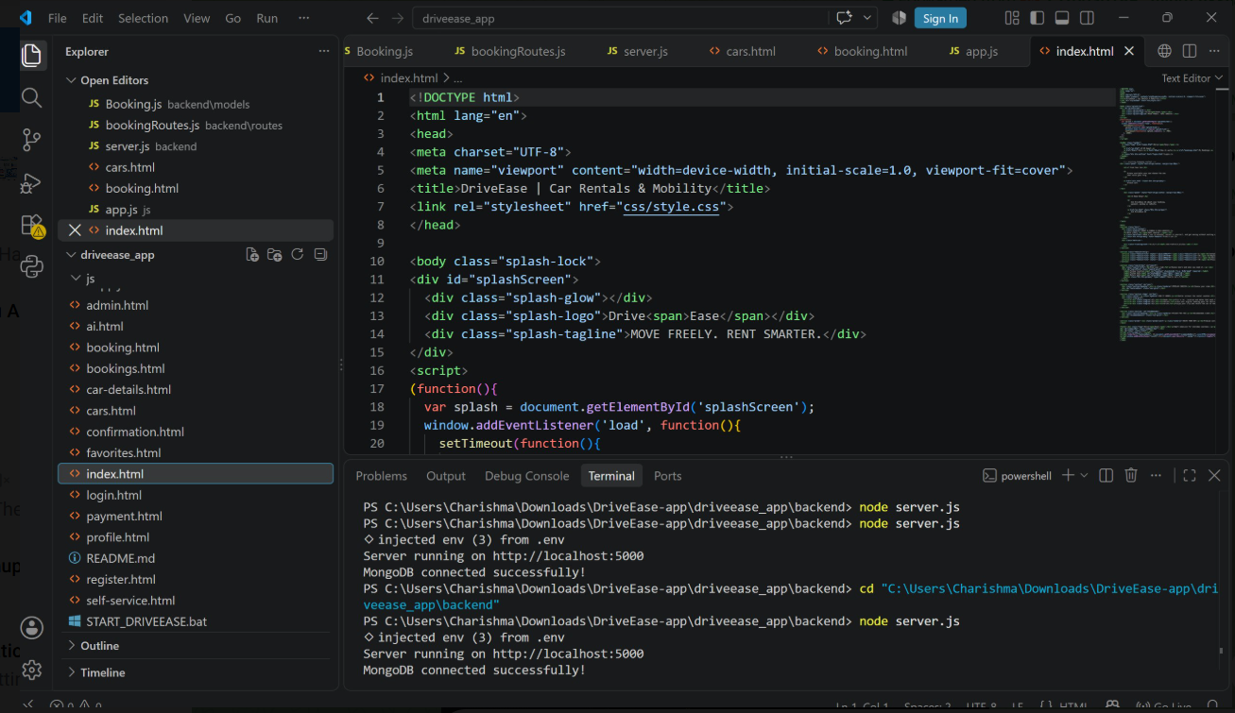
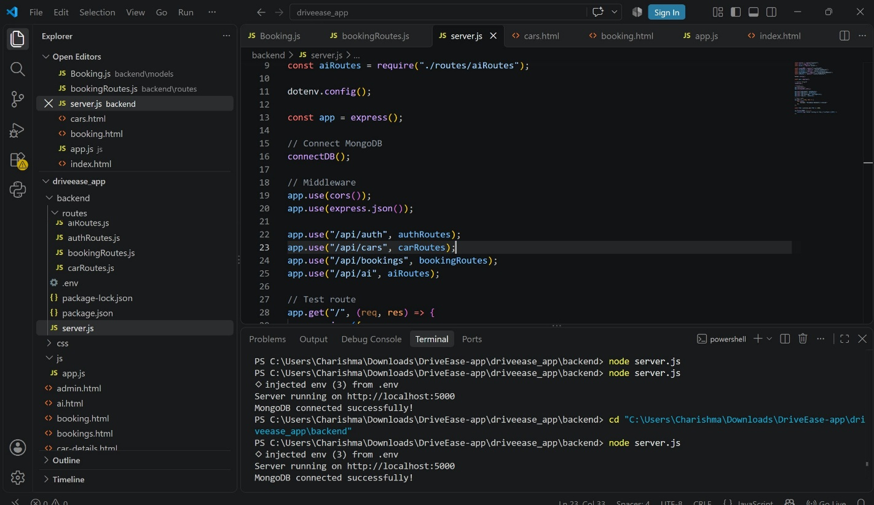
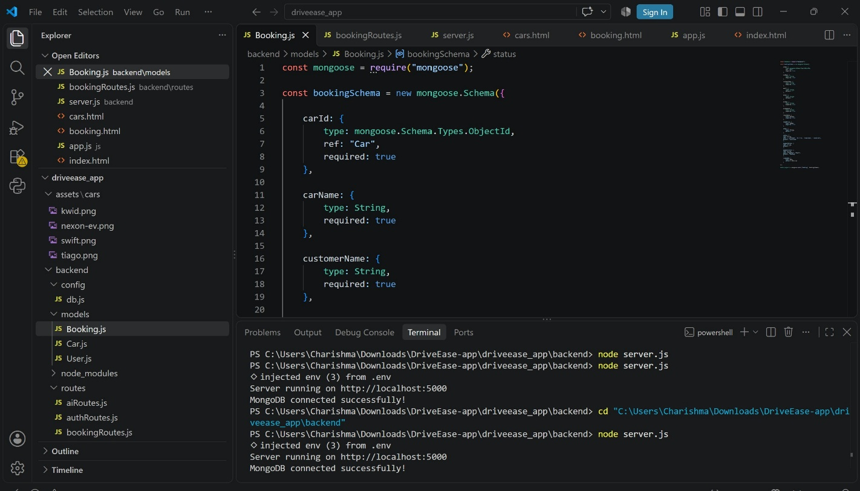

C. Installation / Setup Instructions
- Install Node.js (LTS version) and MySQL 8.
- Download or clone the project folder from GitHub.
- Open a terminal in the project folder and run: npm install.
- Open MySQL Workbench, run schema.sql, txn.sql and the seed data script.
- Create the .env file using the sample in Section 9.2 and enter your MySQL password.
- Run: npm start.
- Open http://localhost:5000 in a web browser.
- Log in with the sample admin account (created in the seed script) to access the dashboard.

D. User Manual / Guide

For customers
- Click Register, fill in your name, email, phone, driving licence number and password.
- Log in with your email and password.
- On the home page, choose the pick-up location, start date/time and end date/time and click Search.
- Use the filters (category, fuel type, seats, price) to narrow the list of available cars.
- Click Book Now on the car you want, check the summary and the total amount and confirm.
- Choose a payment method and complete payment. Your booking status becomes Confirmed.
- Go to My Bookings to view, cancel or track your rental; after the trip, rate it.

For administrators
- Log in with an admin account.
- Use Vehicles to add a vehicle, edit its rate or mark it as under maintenance.
- Use Bookings to monitor all reservations and update pick-up status.
- Use Returns to enter the return time and odometer reading; the system calculates late fees.
- Use Reports to view revenue by month and category.

Geo-Tag Photos with Guide

